Solution 1: Use Azure Integration Services
To deploy an EDI solution on Azure, you’ll almost always build on Azure Integration Services:
- Logic Apps (EDI/B2B engine + workflows)
- Integration Account (partners, agreements, schemas, maps)
- API Management (expose/manage EDI APIs)
- Service Bus / Event Grid / Storage (queues, events, files) Microsoft Learn+1
Below is a practical, step-by-step roadmap you can use as an architect or developer.

1. Choose your EDI patterns
Azure Logic Apps + Integration Account natively support EDI standards:
- X12
- EDIFACT
- AS2
- RosettaNet (Consumption only) Microsoft Learn+1
Typical patterns:
- VAN or partner sends X12/EDIFACT over AS2 → you decode, validate, transform → write to DB/API/queue.
- Your system generates outbound EDI from internal JSON/XML and sends via AS2/FTP/SFTP.
Decide:
- Which protocols? (AS2, SFTP, FTPS, API, etc.)
- Which standards? (X12 4010, 5010, EDIFACT D96A, etc.)
- Real-time (API) vs batch (files in blob/SFTP).

2. Core Azure building blocks
For a modern EDI solution, your baseline Azure resources usually include:
- Azure Logic Apps (Standard or Consumption) – orchestrate flows and run EDI actions. Microsoft Learn
- Integration Account – stores:
  - Trading partners
  - Agreements
  - Schemas
  - Maps
  - Certificates Microsoft Learn+1
- Storage / Service Bus / Event Grid – for decoupling and reliable messaging. Microsoft Learn+1
- API Management – if you want REST APIs in front of your EDI endpoints
3. High-level architecture (inbound example)
Scenario: Partner sends X12 850 Purchase Orders via AS2, you convert and store in your SQL/ERP.
Flow:
- Entry point
  - AS2 or HTTPS endpoint in Logic Apps or behind API Management.
- EDI decode
  - Logic App action: X12 Decode (needs Integration Account with X12 schema + agreement). Microsoft Learn+1
- Validation & acknowledgement
  - Validate against schema.
  - Generate 997/999 (X12) or CONTRL (EDIFACT) acknowledgments back to partner. Microsoft Learn+1
- Transformation
  - XML → internal canonical model (using maps in Integration Account) or directly to JSON.
- Back-end integration
  - Call internal Web API / Azure Functions / Logic App to write into:
    - Azure SQL / SQL Managed Instance
    - On-prem SQL/ERP via On-prem Data Gateway or VPN/ExpressRoute
    - Service Bus queue for downstream processing.
- Monitoring & logging
  - Use Application Insights, Log Analytics, and Logic Apps run history.
4. Step-by-step: build a simple EDI pipeline
Step 1 – Create resource group
In the portal:
- Create a Resource Group, e.g. rg-edi-prod.
Step 2 – Create Integration Account
- Search “Integration accounts” → Create.
- Put it in rg-edi-prod, same region you will use for Logic Apps.
- Inside the Integration Account, configure:
  - Partners
  - Agreements
  - Schemas (X12/EDIFACT)
  - Maps (XSLT transforms) Microsoft Learn+1
Step 3 – Create Logic App (Standard or Consumption)
- Create Logic App.
- Link to the Integration Account (for Consumption; Standard uses it via region/sub). Microsoft Learn+1
- Choose trigger:
  - When an HTTP request is received (API style)
  - When a file is added to blob/SFTP (batch file style).
Step 4 – Add EDI actions
Within the Logic App designer:
- Add Decode X12 message, Decode EDIFACT, or Decode AS2 action.
- Choose:
  - Agreement (host partner = you, guest = trading partner)
  - Message type (e.g. 850, 810, 214). Microsoft Learn+1
The action yields:
- Parsed XML/JSON representation
- Optional acknowledgments.
Step 5 – Transform & map
Options:
- Use maps stored in Integration Account (XSLT) to convert EDI XML → internal canonical XML. Microsoft Learn+1
- Use Logic Apps data operations (Compose, Parse JSON) or call Azure Functions for custom logic.
Step 6 – Deliver to back-end
Common patterns:
- Call your ASP.NET Core API on App Service.
- Drop a message into Service Bus Queue/Topic for downstream processing.
- Write directly to Azure SQL via Logic Apps connector.
5. Outbound EDI flow
Reverse of inbound:
- Internal system (ERP / API) produces canonical JSON/XML.
- Logic App:
  - Maps canonical to EDI XML using map.
  - Uses Encode X12/EDIFACT action with correct agreement.
  - Sends via AS2, SFTP, FTP, or API to partner.
- Generates and tracks outbound acknowledgments.

6. DevOps & lifecycle
To treat your EDI solution like a real app:
- Store Logic App definitions, maps, and schemas in Git (GitHub/Azure DevOps).
- Use ARM/Bicep/Terraform or Azure DevOps Pipelines/GitHub Actions for CI/CD.
- Use parameterized templates to deploy same logic to Dev/Test/Prod with different:
  - Connection strings
  - Partner IDs
  - Endpoints.
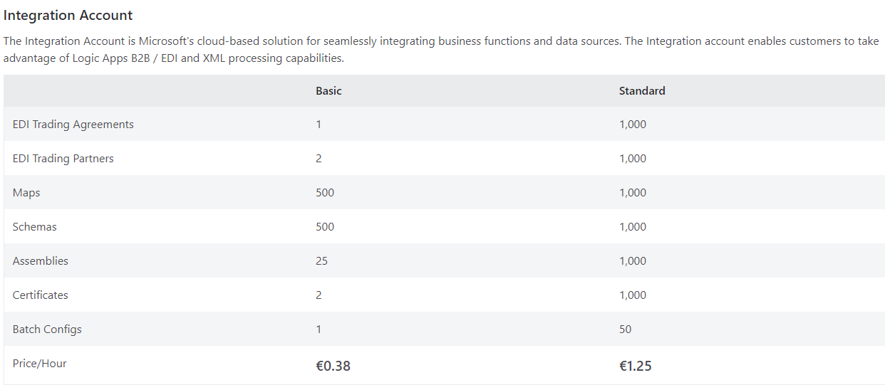

🎯 What “typical real-world EDI” might cost
- Small business / low-volume EDI (1–2 partners, few messages per day): probably US $50–300/month (mostly the Integration Account).
- Mid-size scenario (several partners, daily message volumes, transformations, DB writes): US $300–1,000/month.
- Enterprise / high-volume EDI (many partners, heavy traffic, many workflows, high reliability): could be US $1,000–2,000+/month, especially when adding DB storage, monitoring, networking, etc.
Expensive DO NOT USE

